**USE CASES DIAGRAMS**

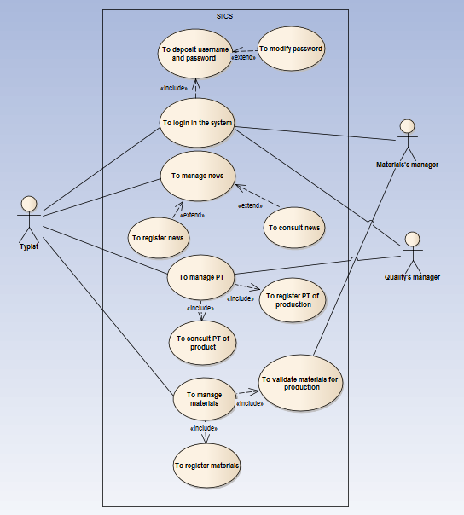

Good evening.

We are the GAES one, my name is Joselin Dussan and my partners David Duque and Cesar Sanchez, we are going to explain our use case diagram, this diagram is the most important of our information system. This use case diagram has three actors (Typist, Materials’s manager and Quality’s manager), we started with the Typist actor, the Typist to login in the system same the other actors. The include is to deposit username and password and the extend is to modify password. The Typist manages news and the extends are to register news and to consult news. The Typist and the Quality’s manager manages PT and the includes are to register PT of production and to consult PT of production. And to finish we look here the Typist manages materials where include is to register materials and to validate materials for production and the Materials’s manager only validates materials for production.